**Department of Electrical Engineering and   
Computer Science**

**Faculty Member:** Dr. Mohsin Kamal **Dated:** 30/11/2023

**Semester:** 7th **Section:** BEE 12C

**CS-477 Computer Vision**

Lab 11: Image Stitching

**Group Members**

|  |  |  |  |  |  |  |
| --- | --- | --- | --- | --- | --- | --- |
|  |  | **PLO4 - CLO4** | | **PLO5 -CLO5** | **PLO8 -CLO6** | **PLO9 -CLO7** |
| **Name** | **Reg. No** | **Viva / Quiz / Lab Performance** | **Analysis of Data in Lab Report** | **Modern Tool Usage** | **Ethics and Safety** | **Individual and Teamwork** |
|  |  | **5 Marks** | **5 Marks** | **5 Marks** | **5 Marks** | **5 Marks** |
| Muhammad Ahmed Mohsin | 333060 |  |  |  |  |  |
| Muhammad Umer | 345834 |  |  |  |  |  |
|  |  |  |  |  |  |  |
|  |  |  |  |  |  |  |

**Table of Contents**

2 Image Stitching 3

2.1 Introduction 3

2.2 Objectives 3

2.3 Software 3

3 Lab Task 4

3.1 Input Images 4

3.2 Keypoint Detection & Descriptors 4

3.3 Feature Matching 6

3.4 Homography Estimation 7

3.5 Image Warping & Blending 7

3.6 Comparison of Feature Detection Algorithms 9

4 Conclusion 11

# Image Stitching

## Introduction

Image stitching stands as a technique to craft composite images, such as panoramic views, by combining multiple overlapping photographs. This method extends the capacity to capture more information and constructs a broader field of view compared to the limitations of a single image. Industries spanning photography, virtual reality, and robotics extensively leverage image stitching.

## Objectives

The objective of this lab is:

* Stitch two images to create panoramic image

## Software

OpenCV is a library that focuses on image processing and computer vision. An image is an array of colored squares called pixels. Each pixel has a certain location in the array and color values in BGR format. By referring to the array indices, the individual pixels or a range of pixels can be accessed and modified. OpenCV provides many functions for resizing, rotating, and placing objects in images. Rotation involves computing a 2-D rotation matrix which is applied for the transformation of the image.



# Lab Task

Implement an image stitching pipeline to create a panorama from two or three images, which you can download from the internet. Justify and explain the choice of libraries and algorithms at each stage of the image stitching pipeline. Compare panoramas created as a result of choosing different feature detection algorithms.

## Input Images

We choose the following images as the left and right images to be stitched together for the creation of the panorama.

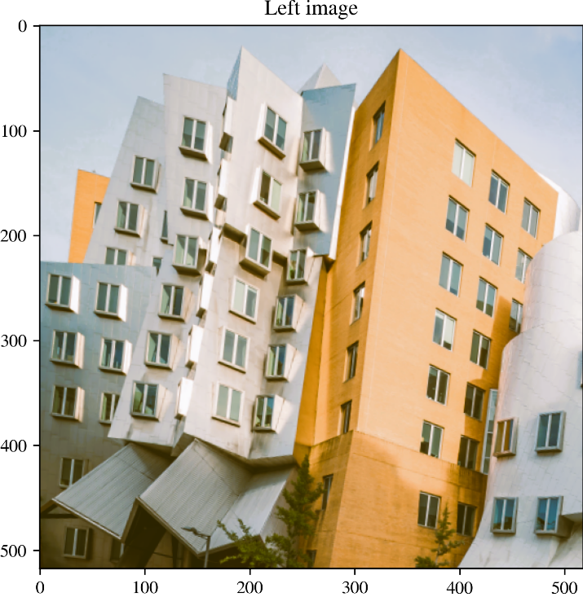 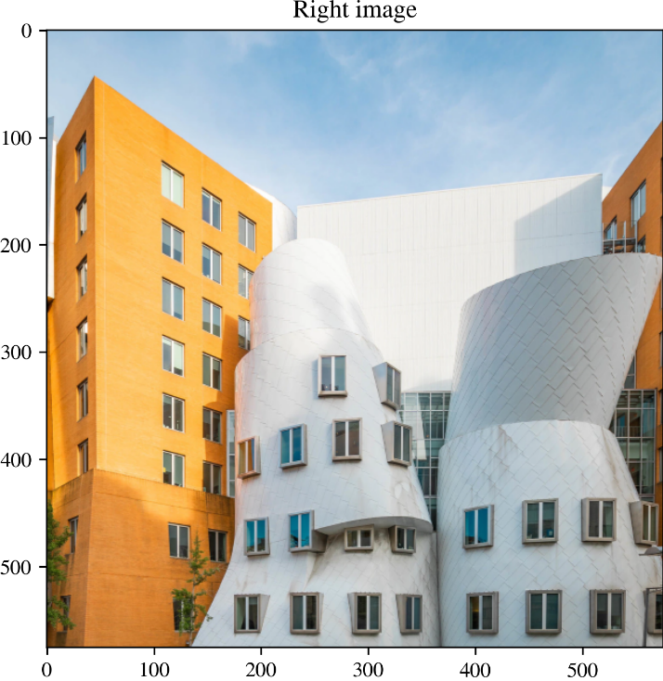

## Keypoint Detection & Descriptors

The initial stage of our image stitching pipeline involved the simultaneous extraction of keypoints and descriptors using the Scale-Invariant Feature Transform (SIFT) algorithm. Implemented through OpenCV, SIFT ensures the detection of distinctive keypoints in images and computes descriptors for these keypoints. This joint approach enhances the robustness of feature extraction, crucial for subsequent matching stages.

*# Load the images*

img1_path = "left.png"

img2_path = "right.png"

img1 = cv2.imread(img1_path)

img2 = cv2.imread(img2_path)

plt.imshow(img1[:, :, ::-1])

plt.tight_layout()

plt.savefig("plt_left.png", *dpi*=300, *bbox_inches*="tight", *pad_inches*=0)

plt.imshow(img2[:, :, ::-1])

plt.tight_layout()

plt.savefig("plt_right.png", *dpi*=300, *bbox_inches*="tight", *pad_inches*=0)

*# Extract keypoints and descriptors using SIFT*

kp1, descriptors1 = cv2.SIFT_create().detectAndCompute(img1, None)

kp2, descriptors2 = cv2.SIFT_create().detectAndCompute(img2, None)

*# Visualize keypoints*

img1_kp = cv2.drawKeypoints(img1, kp1, None, *flags*=cv2.DRAW_MATCHES_FLAGS_DRAW_RICH_KEYPOINTS)

img2_kp = cv2.drawKeypoints(img2, kp2, None, *flags*=cv2.DRAW_MATCHES_FLAGS_DRAW_RICH_KEYPOINTS)

plt.imshow(img1_kp[:, :, ::-1])

plt.tight_layout()

plt.title("Keypoints on left image")

plt.savefig("plt_left_kp.png", *dpi*=300, *bbox_inches*="tight", *pad_inches*=0)

plt.imshow(img2_kp[:, :, ::-1])

plt.tight_layout()

plt.title("Keypoints on right image")

plt.savefig("plt_right_kp.png", *dpi*=300, *bbox_inches*="tight", *pad_inches*=0)

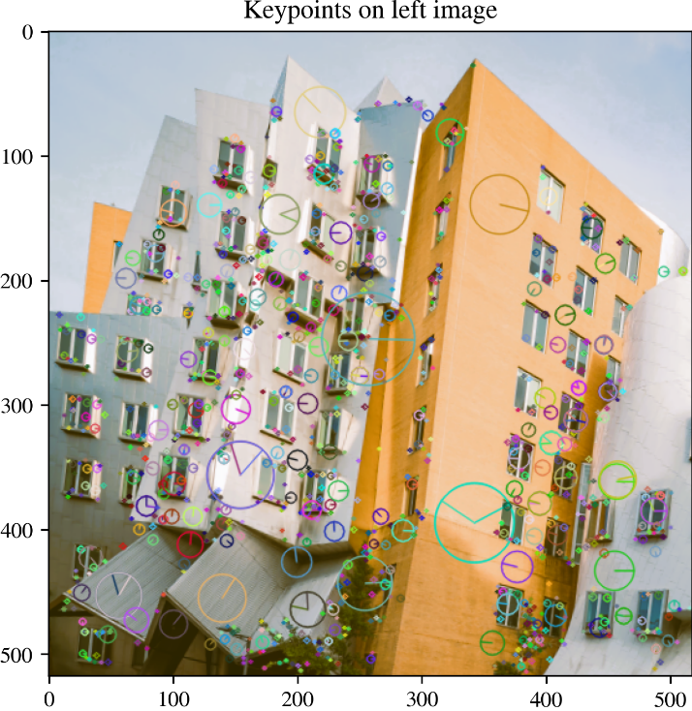 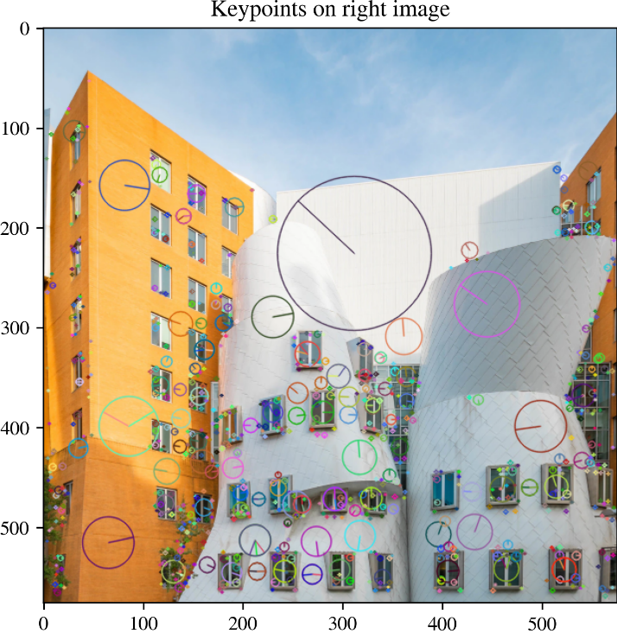

## Feature Matching

In the feature matching stage, a brute-force matcher with a ratio test was applied. Implemented through OpenCV's BFMatcher, this approach efficiently pairs keypoints between the two images. The ratio test filters out erroneous matches, providing a set of high-quality correspondences for subsequent processing.

*# Set parameters for matching*

ratio = 0.75

min_match = 10

smoothing_window_size = 200

*# Brute force matcher*

matcher = cv2.BFMatcher()

raw_matches = matcher.knnMatch(descriptors1, descriptors2, *k*=2)

*# Filter the matches using the ratio test*

good_points = []

good_matches = []

for m1, m2 in raw_matches:

    if m1.distance < ratio * m2.distance:

        good_points.append((m1.trainIdx, m1.queryIdx))

        good_matches.append([m1])

plt.imshow(

    cv2.drawMatchesKnn(img1, kp1, img2, kp2, good_matches, None, *flags*=2)[:, :, ::-1]

)

plt.tight_layout()

plt.savefig("plt_matches.png", *dpi*=300, *bbox_inches*="tight", *pad_inches*=0)

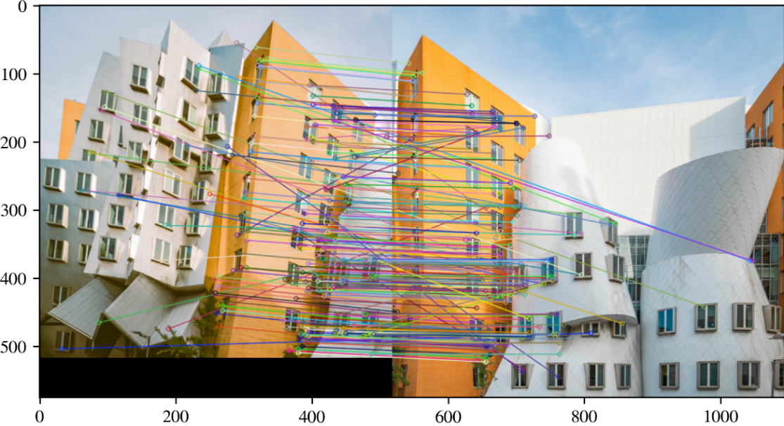

## Homography Estimation

RANSAC (Random Sample Consensus) was employed to estimate the homography matrix, crucial for aligning images properly. This robust method handles outliers effectively, ensuring accurate perspective transformation between images.

if len(good_points) > min_match:

    image1_kp = np.float32([kp1[i].pt for (_, i) in good_points])

    image2_kp = np.float32([kp2[i].pt for (i, _) in good_points])

    H, status = cv2.findHomography(image2_kp, image1_kp, cv2.RANSAC, 5.0)

else:

    raise *AssertionError*(

        Fore.RED

        + Style.BRIGHT

        + "Error: Not enough matches were found - %d/%d" % (len(good_points), min_match)

        + Style.RESET_ALL

    )

## Image Warping & Blending

The calculated homography matrix was utilized to warp one image onto the perspective of the other. This step, implemented through OpenCV's warpPerspective function, ensures proper alignment and creates the basis for the panoramic view. To seamlessly merge the warped images, a blending technique was applied. A mask, gradually transitioning from one image to the other, was created to avoid abrupt transitions. This blending process, implemented through custom masks, contributes to a visually pleasing and coherent panorama.

*# Function to create a mask for blending*

*def* create_mask(*img1*, *img2*, *version*):

*# Calculate dimensions*

    height_img1 = img1.shape[0]

    width_img1 = img1.shape[1]

    width_img2 = img2.shape[1]

    height_panorama = height_img1

    width_panorama = width_img1 + width_img2

    offset = *int*(smoothing_window_size / 2)

    barrier = img1.shape[1] - *int*(smoothing_window_size / 2)

    mask = np.zeros((height_panorama, width_panorama))

*# Create mask*

    if version == "left_image":

*# Increase linearly from 1 to 0 from left to right*

        mask[:, barrier - offset : barrier + offset] = np.tile(

            np.linspace(1, 0, 2 * offset).T, (height_panorama, 1)

        )

        mask[:, : barrier - offset] = 1

    elif version == "right_image":

*# Increase linearly from 0 to 1 from left to right*

        mask[:, barrier - offset : barrier + offset] = np.tile(

            np.linspace(0, 1, 2 * offset).T, (height_panorama, 1)

        )

        mask[:, barrier + offset :] = 1

    return cv2.merge([mask, mask, mask])  *# Across all three channels*

*# Calculate dimensions for panorama*

height_img1 = img1.shape[0]

width_img1 = img1.shape[1]

width_img2 = img2.shape[1]

height_panorama = height_img1

width_panorama = width_img1 + width_img2

*# Create panorama with left image*

panorama1 = np.zeros((height_panorama, width_panorama, 3))

mask1 = create_mask(img1, img2, *version*="left_image")

panorama1[0 : img1.shape[0], 0 : img1.shape[1], :] = img1

panorama1 *= mask1

*# Create panorama with right image*

mask2 = create_mask(img1, img2, *version*="right_image")

panorama2 = cv2.warpPerspective(img2, H, (width_panorama,

height_panorama)) * mask2

*# Combine panoramas and crop*

result = panorama1 + panorama2

left = 0

right = result.shape[1]

for col in range(result.shape[1]):

    if np.sum(result[:, col]) != 0:

        left = col

        break

for col in range(result.shape[1] - 1, 0, -1):

    if np.sum(result[:, col]) != 0:

        right = col

        break

result = result[:, left:right, :]

*# Convert to uint8 and clip to range 0-255*

panorama = np.clip(result, 0, 255).astype(np.uint8)

*# Display and save the result*

plt.imshow(panorama[:, :, ::-1])

plt.tight_layout()

plt.savefig("plt_stitched.png", *dpi*=300, *bbox_inches*="tight", *pad_inches*=0)

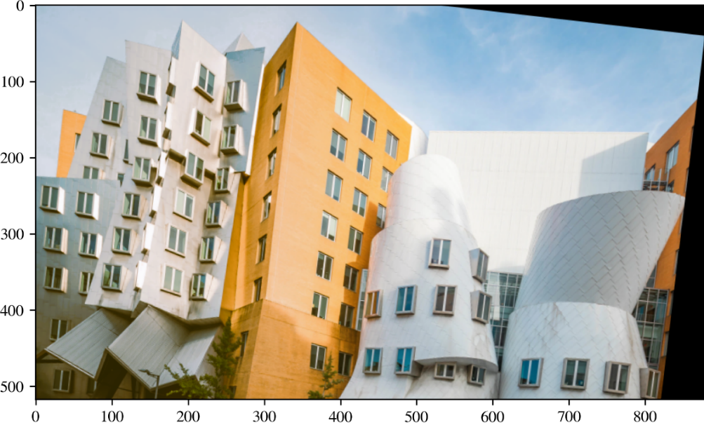

## Comparison of Feature Detection Algorithms

To compare the results obtained from SIFT, we also implement the panorama stitching using ORB. It constitutes a change of two lines of code in the previous framework, as shown in the following:

*# Extract keypoints and descriptors using ORB*

kp1, descriptors1 = cv2.ORB_create().detectAndCompute(img1, None)

kp2, descriptors2 = cv2.ORB_create().detectAndCompute(img2, None)

We obtain the following feature matches and the panoramas:

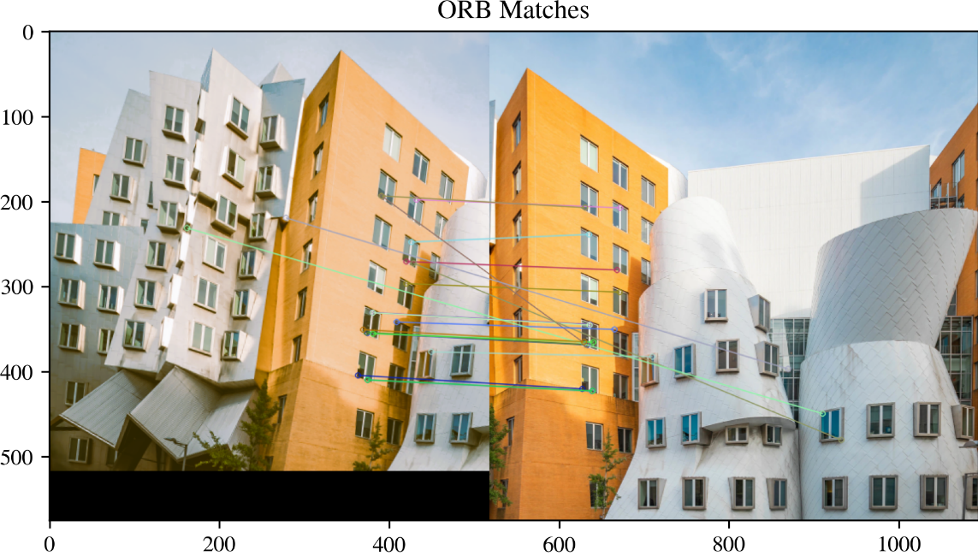

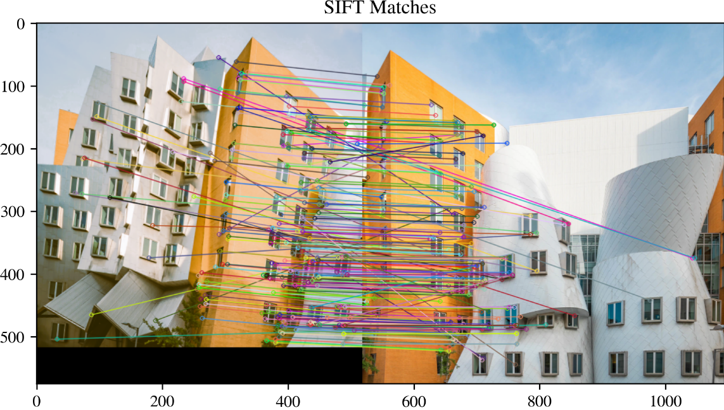

There is a noticeable contrast in the number of matches obtained from SIFT as opposed to ORB, and this discrepancy can be ascribed to the distinctive attributes inherent in each algorithm. SIFT excels in the intricate capturing and depiction of unique features within an image, imparting resilience to variations in scale, rotation, and illumination. This is achieved through the utilization of a Gaussian scale space representation, identifying keypoints at various scales and orientations. Conversely, Oriented FAST and Rotated BRIEF (ORB) prioritizes efficiency, employing a binary descriptor that is computationally less demanding. Although ORB boasts faster performance and is well-suited for real-time applications, it may encounter challenges in capturing the full richness of features present in images, resulting in a diminished number of matches.

We also compare the panoramas thus obtained:

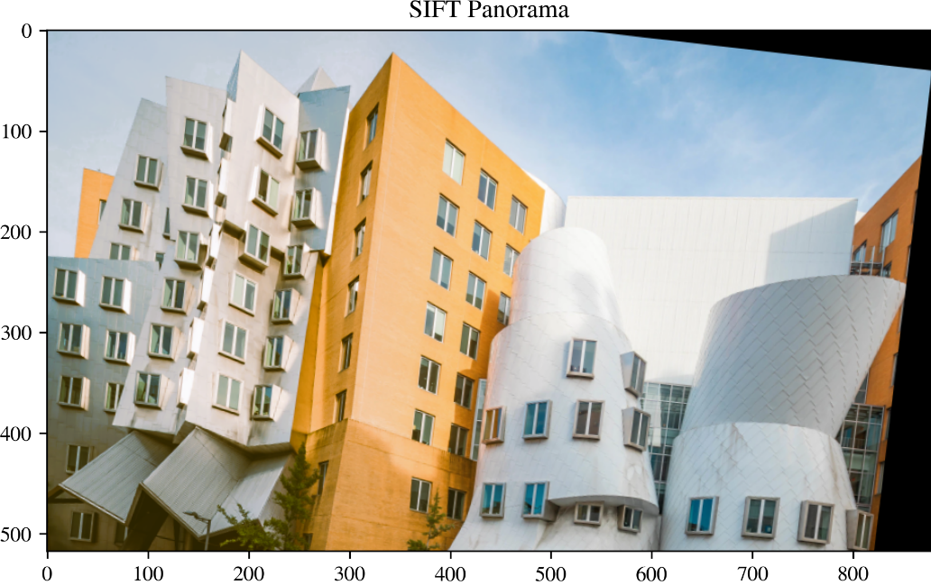

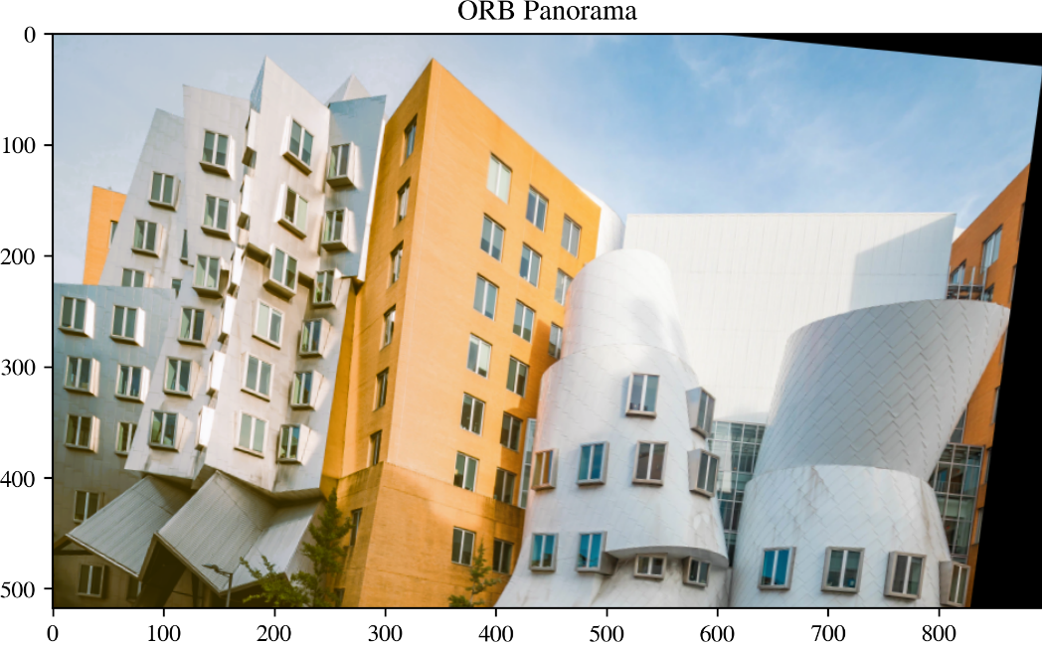

While ORB produces fewer feature matches than SIFT, the resulting panorama is still deemed satisfactory, and this can be credited to the inherent simplicity of the image. ORB, tailored for computational efficiency, proves more effective in scenarios where the visual content is relatively uncomplicated, lacking intricate details or variations in scale and rotation. In instances where the scene features a simpler composition and fewer distinctive elements, ORB's capacity to efficiently detect and match keypoint descriptors becomes adequate for constructing a cohesive panorama.

# Conclusion

In conclusion, through the exploration of image stitching in this lab, we successfully achieved our objective of stitching two images to create a panoramic view. This technique proves to be a valuable tool in various industries, enhancing our ability to capture and visualize expansive scenes beyond the constraints of individual photographs.